DSA (C++) NOTES

ARRAYS
An array in C/C++ or be it in any programming language is a collection of similar data items stored at contiguous memory locations and elements can be accessed randomly using indices of an array. They can be used to store collection of primitive data types such as int, float, double, char, etc of any particular type.

Advantages of an Array in C/C++:
- Random access of elements using array index.
- Use of less line of code as it creates a single array of multiple elements.
- Easy access to all the elements.
- Traversal through the array becomes easy using a single loop.
- Sorting becomes easy as it can be accomplished by writing less line of code.
Facts about Array in C/C++:
Array elements are accessed by using an integer index. Array index starts with 0 and goes till size of array minus 1.
Name of the array is also a pointer to the first element of array.

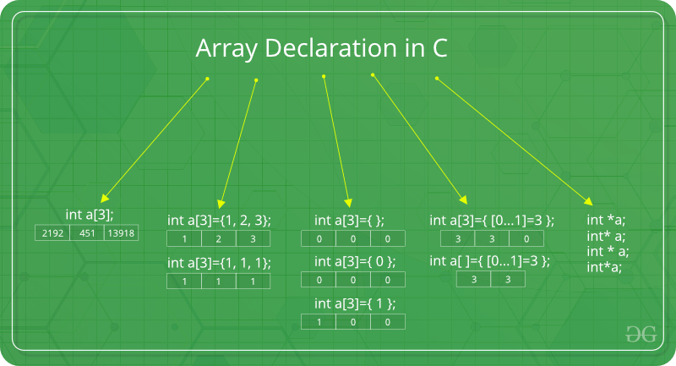
No Index Out of bound Checking:
There is no index out of bounds checking in C/C++, for example, the following program compiles fine but may produce unexpected output when run.

What is vector in C++?
A vector in C++ is a class in STL that represents an array. The advantages of vector over normal arrays are,

- We do not need pass size as an extra parameter when we declare a vector i.e, Vectors support dynamic sizes (we do not have to initially specify size of a vector). We can also resize a vector.
- Vectors have many in-built function like, removing an element, etc.

